Transistor

Bipolar Junction Transistors (BJT)

NPN
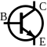
Transistor is on when the Base-Emitter (B-E) voltage is positive (i.e. the voltage at the Base (B) should be higher than the voltage at the Emitter (E)). The collector (C) is positive. The Emitter (E) is negative.

PNP
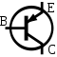
Transistor is on when the Base-Emitter (B-E) voltage is negative (i.e. the voltage at the Base (B) should be lower than the voltage at the Emitter (E)). The Emitter (E) is positive. The Collector (C) is negative.

Field Effect Transistors (FET)
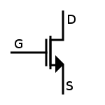
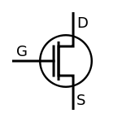
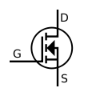
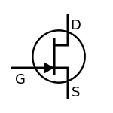

N Channel

When the Gate (G) is high, the transistor will pass current from the Drain (D) to the Source (S). N-channel FETs also conduct current from the Source (S) to the Drain (D) regardless of whether they are “on” or “off”.

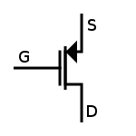
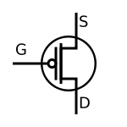
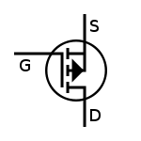
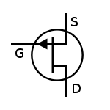
P Channel

When the Gate (G) is low, the transistor will pass current from the Source (S) to the Drain (D). P-channel FETs also conduct current from the Drain (D) to the Source (S) regardless of whether they are “on” or “off”.

FET BJT
Gate ~ Base
Source ~ Emitter
Drain ~ Collector

